**Harrington Park Historical Society**

**Meetings and Events**

**2024-2025**

The Harrington Park Historical Society holds General Meetings the first Monday of every month (except where otherwise noted) September through June in the Harrington Park Library (second floor). The meetings begin at 7:30 P.M. and include a lecture by a guest speaker on various topics of history, followed by a reception. Our meetings are open to everyone.

**The Harrington Park Historical Society is a non-profit 501(c)(3) Corporation**

**September 9, 2024**– General Meeting

Speaker: Francesca Costa, Historian Palisades Interstate Park

Topic: “Skunk Hollow”

**October 7, 2024**– General Meeting

Speaker: Mario Medici, Historian, Lecturer, Owner of Medici Tours

Topic: “A History of Greenwich Village; 400 years of Tragedy, Bohemians, and the Arts”

**November 4, 2024** – General Meeting

Speaker: Charles Dewey, Historian Ft. Lee Historic Park

Topic: “Terror in the Ramapos: Claudius Smith & the American Revolution”

**December 2, 2024** – Holiday Outing

Speaker: Mark Wright, Jazz Pianist

’76 House Restaurant, Tappan, NY

Hors d'oeuvres & Sweets, Cash Bar

Reservation Only – Fee

Details to follow on website.

**January 6, 2025** – General Meeting

Speaker: Melissa Ziobro, History Professor Monmouth University

Topic: TBD

**February 2, 2025** – General Meeting

Speaker: William “Pat Schuber” – Historian, Lecturer, former Bergen County Executive

Topic: “Italian Campaign of WW11”

**March 3, 2025** – General Meeting

Speaker: James Calaski, Historian, Detective Lt. Glen Rock Police Dept.

Topic: “The Hindenburg Disaster – Accident or Sabotage”

**April 7, 2025 –** General Meeting

Speaker: Rick Feingold, Professor Bergen Community College, Historian

Topic: “Miracle Mets of 1969”

**May 5, 2025**

Speaker: Richard Viet, Professor Monmouth University, Historian

Topic: “A Monument to Fallen Royalty”

**June 2, 2025**– General and Society

Speaker: Eric Nelsen, Historical Interpreter Palisades Interstate Park

Topic: TBD

**June 14, 2025** – “Members’ Pot Luck Picnic” - 4:00 P.M. at Gerri Gibney’s

**Special Note:**

Please check our web site for Arts Council Events during the 2025 season. We are anticipating several concerts!

**Proud Sponsor of the**

**Harrington Park Arts Council**

***"The Art of Today - The History of Tomorrow!"***

**Membership Information**

Membership is open to all who are interested in the aims of the Society

Annual Dues:

Individual $30.00

Family $35.00

Youth $5.00 (under 18)

Please note members receive a discount on all Society Events and Activities.

Listed below are Volunteer Opportunities. As a member you can enjoy our lectures, or you might feel the need to be more “hands-on” – it is up to you.

**Volunteer Opportunities**

1. Docent – The Society has “History Hikes” as well as tours of historical homes and neighborhoods. If you enjoy people, and learning local history – this is for you.

2. Archivist – One of our primary functions is to preserve and catalog the history of Harrington Park.

3. Research – Plenty of opportunity here, either on your own or as part of a group for a specific project.

4. Hosts and Hostesses – Volunteers to prepare and serve refreshments are always needed at the membership meetings and special events.

5. H.P. Society Newsletter Author – The editor of the Society Newsletter welcomes articles of local historical interest, as well as personal recollections of earlier days in H.P.

6. Special Projects – This will include the preservation of the Old Burying Ground and Perry Cemeteries, as well as other endeavors.

7. Other – Let us know how you would like to help, and your area of expertise.

**Mailing Address and Contacts**

Mailing address for all correspondence, membership and donations is:

Harrington Park Historical Society

P.O. Box 105

Harrington Park, N. J. 07640-0105

Visit us on Facebook or

www.harringtonparkhistoricalsociety.com

General Information:

Gerri Gibney, President

201 768-2615

[themerchantmouse@aol.com](mailto:themerchantmouse@aol.com)

Membership:

Karen Goddard, Chair

201 666-0566

klgoddard@optonline.net

Cemetery Project:

Lou Apa

(201) 767-8325

louisapa@yahoo.com

**Harrington Park**

**Historical Society**

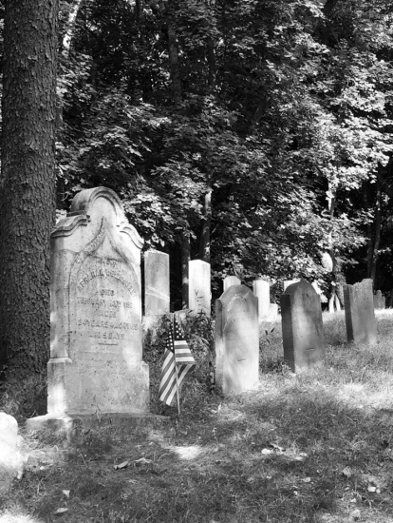

**Photo by Dr. Davis Ross**

**Meetings**

**and**

**Events**

**2024 – 2025**

**P.O. Box 105**

**Harrington Park,**

**N. J. 07640-0105**