Membership Information

The Harrington Park Historical Society's Mission Statement reads:

The purpose of this organization is to discover, conserve, and make more widely

known the history of Harrington Park, New Jersey, and its setting within the region.

In addition to carrying out its stated Mission, the Society conducts ten general meetings a year, from September to June. The meetings have a guest speaker on local, regional, or history at-large topics – or visits to nearby historic sites, followed by refreshments and much good conversation. We encourage participation in the Society, and have many volunteer opportunities available for our members. Meetings are held the first Monday of every month (September*- June) at 7:30 P.M. in the Quantmeyer meeting

room of the Harrington Park Library. For more information, please contact our President, Gerri Gibney

at 201-768-2615 or Membership Secretary, Karen Goddard at 201- 666-0566.

*\* In September, the 1st Monday after Labor Day.*

**2024 - 2025 MEMBERSHIP APPLICATION**

**Membership is open to all who are interested in the aims of the Society**

**You may also contribute and/or donate with the QR Codes shown below!**

Annual Membership Categories are: Family $35 ________

Single $30 ________

(Under 18) Youth $5 ________

I/We would like to support the Harrington Park Historical Society with an additional tax-deductible contribution of:

_______$10 _______$25 _______$50 _______$100 _______$ other

to be applied to _____Operating, _____Cemeteries, _____Building Fund TOTAL:_________________

**PLEASE MAKE CHECKS PAYABLE TO:**

HARRINGTON PARK HISTORICAL SOCIETY

Name(s):___________________________________________________________________________________________________________________

Address:___________________________________________________________________________________________________________________Phone:___________________________________________

E-mail:______________________________________________________________________________________________________________________

**You may contribute by using the** **QR Code through Zeffy**

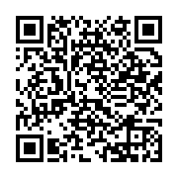HPHS Donation Code 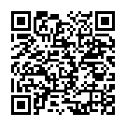HPHS Membership Code